In an Annual Event at IIT , Kharagpur as a Panelist for “The Leadership Summit 2019 “ , inagurated by NOBLE PEACE PRIZE WIINER
PROFESSOR MUHAMMAD YUNUS ( DT. Feb 2 ‘2019 )
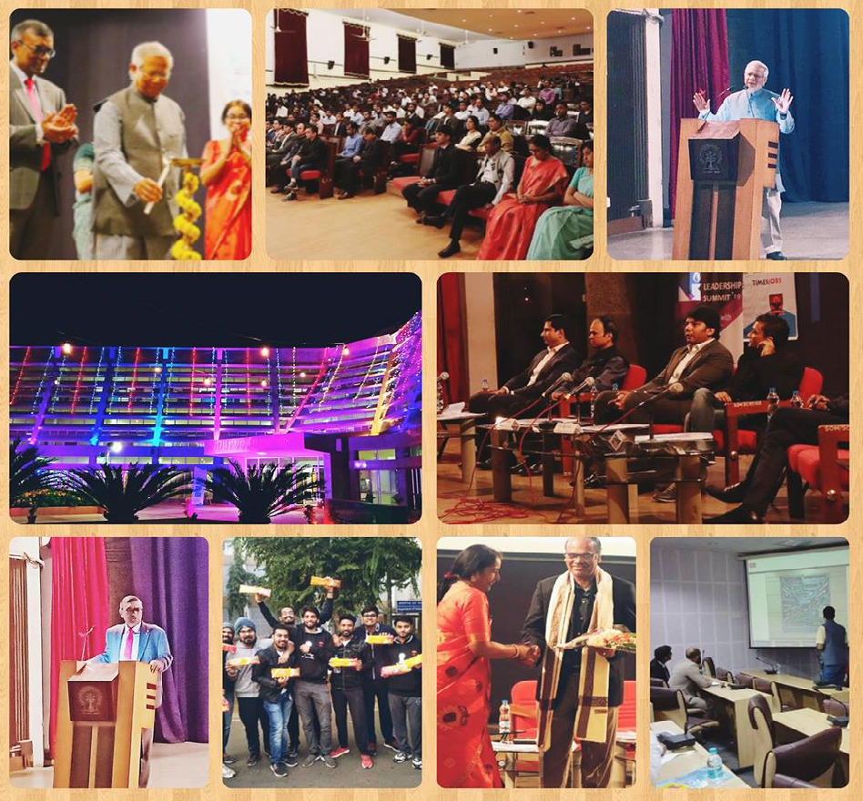
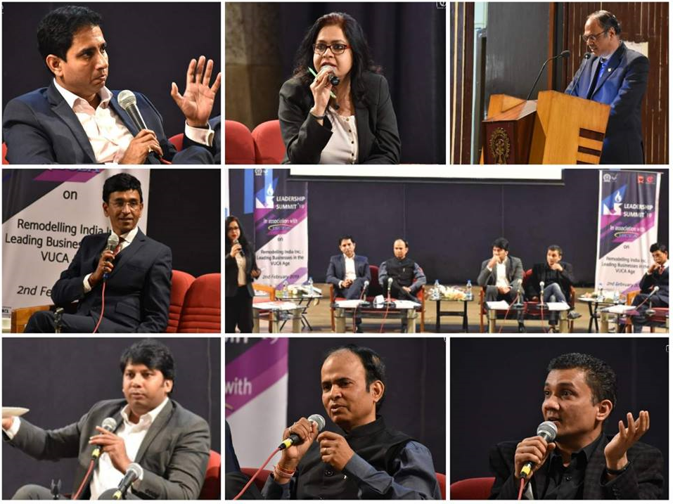

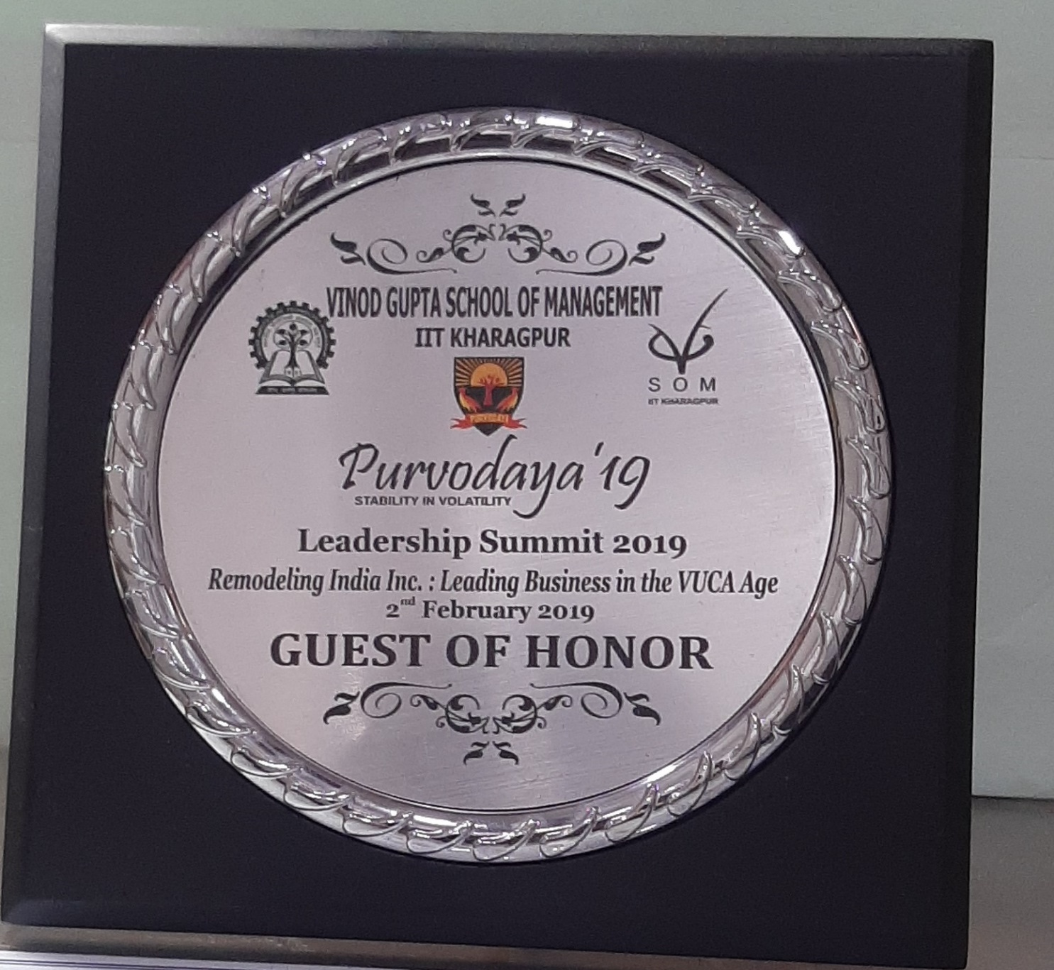

A previleged Interaction with Noble Peace Laureate - Professor Muhammad Yunus at IIT Kharagpur , dt. Feb2 ‘2019

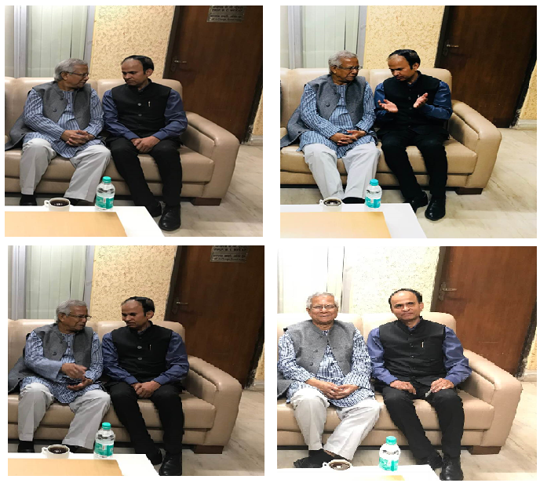

Mr Animesh Kumar at NITIE as a Member of the Jury Panel to judge the Best among the Finalists from Top Mgmt. Colleges of IIT Bombay , IIT Chennai , IIM Indore , NITIE & NMIMS ,
dated Oct 24 2019 .
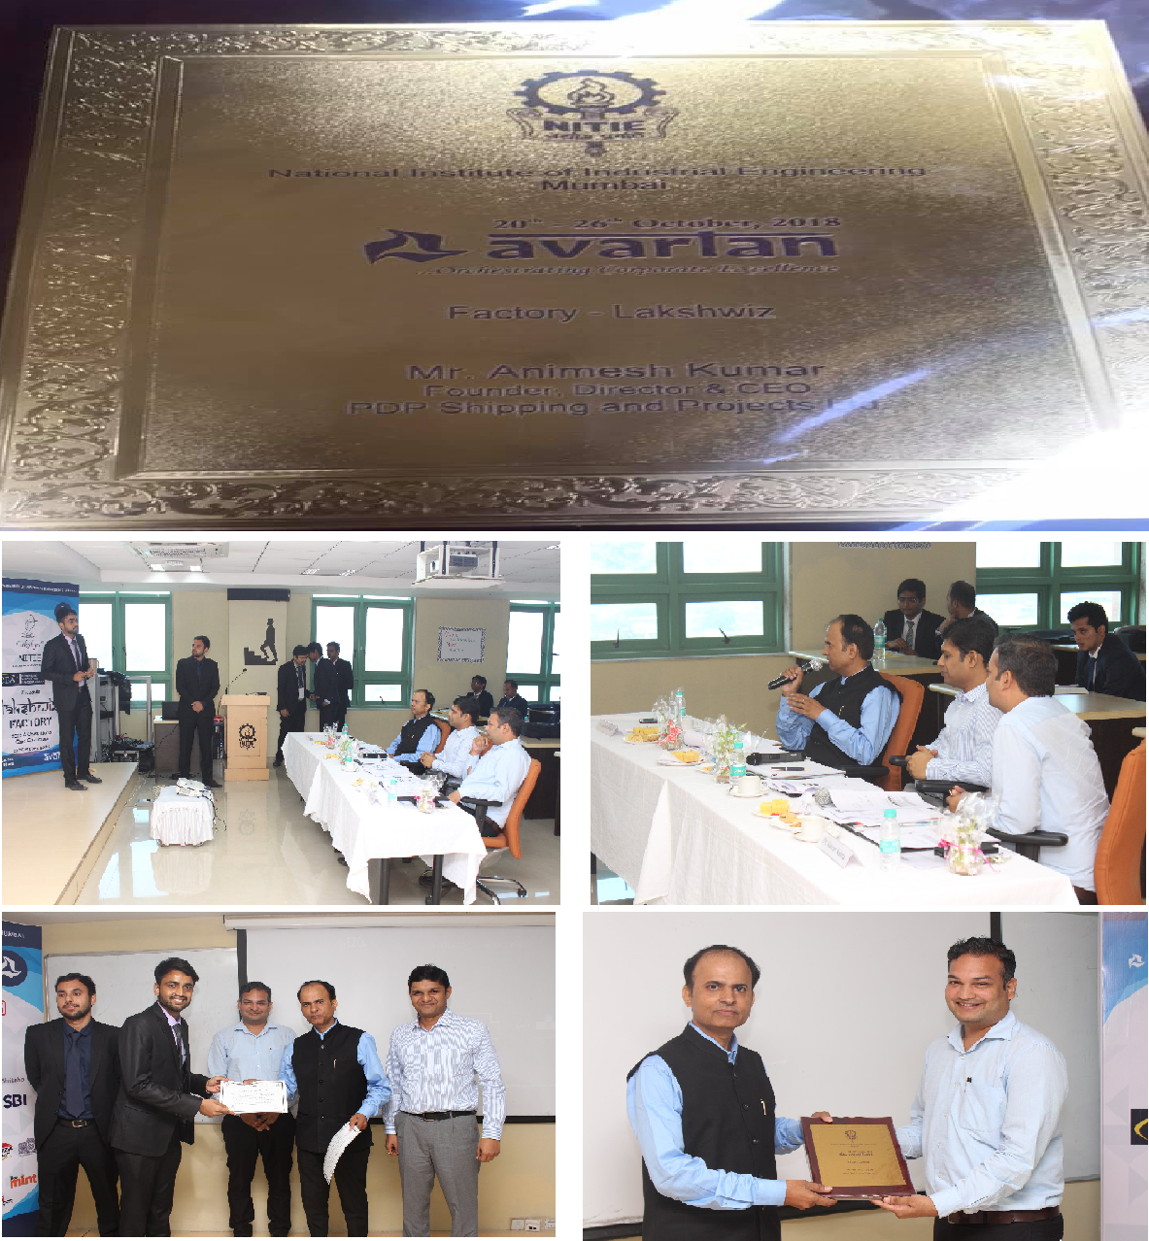

As a Panel Speaker for “ Challenges & Opportunities in Project Cargo & Auto Logistics in India “ at CARGOSHOP at Hyatt , Pune , dated Oct 13 , 2019.

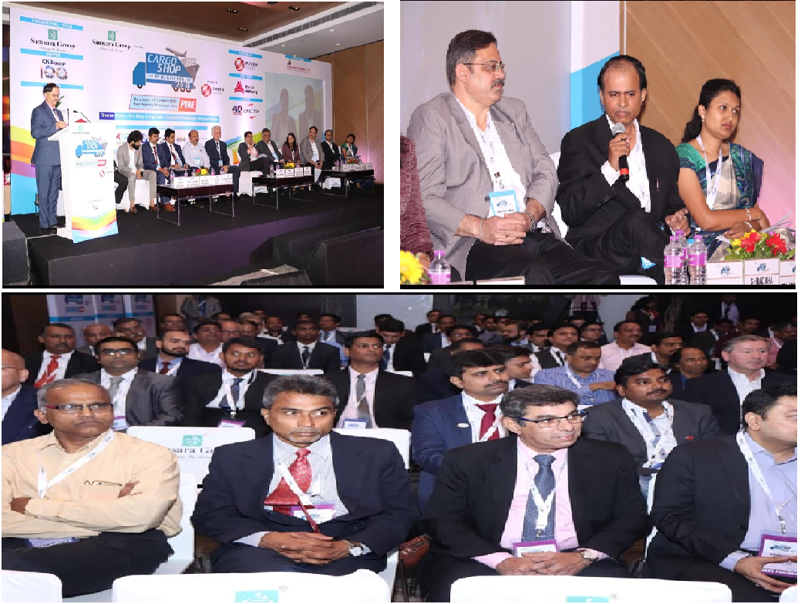

In a Panel Discussion on “ Project Logistics in India” at “BHP-2019 “ at
Hotel Lalit , Mumbai on 31/01/2019

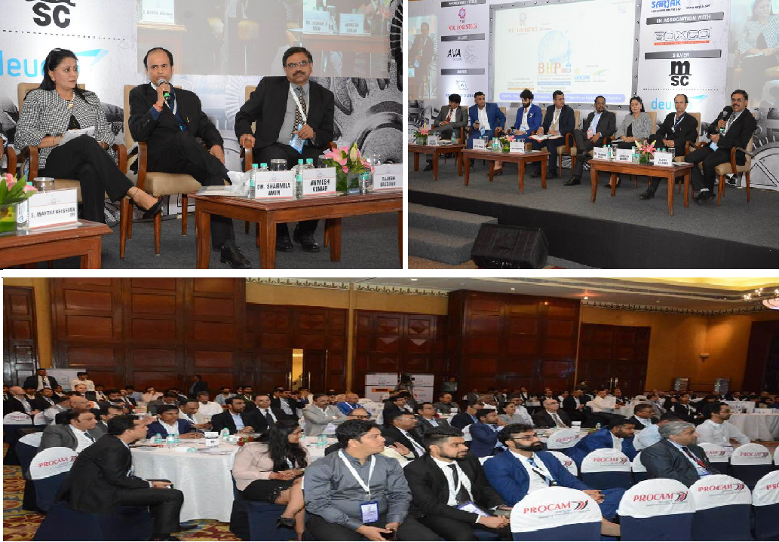

Mr Animesh Kumar With Legends - Nikhil Bhai Modi ( Chief Editor EXIM INDIA NEWS ) & Capt BVJK Sharma ( Director , Adani Ports & SEZ ) at 10th Maritime & Logistics Awards’ 2019

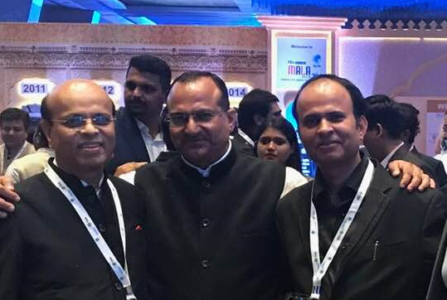

Presenting awards along-with
Mr. B. Narayan , Group President of Reliance Industries Limited to the achievers at the prestigious MALA event ‘ 2019

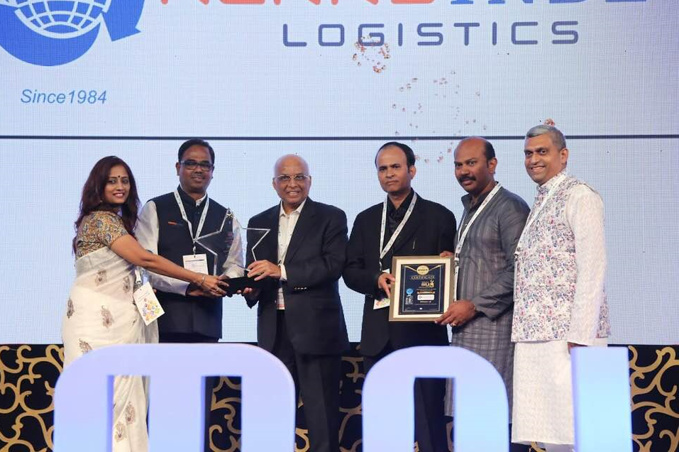

Presenting an award of Excellance alongwith Mr. Sanjay Bhatia , IAS & Chairman of
Mumbai Port Trust at “ Maritime & Logistics Awards -2018 “ , at St. Regis Hotel ,
Mumbai on 31/08/2018.

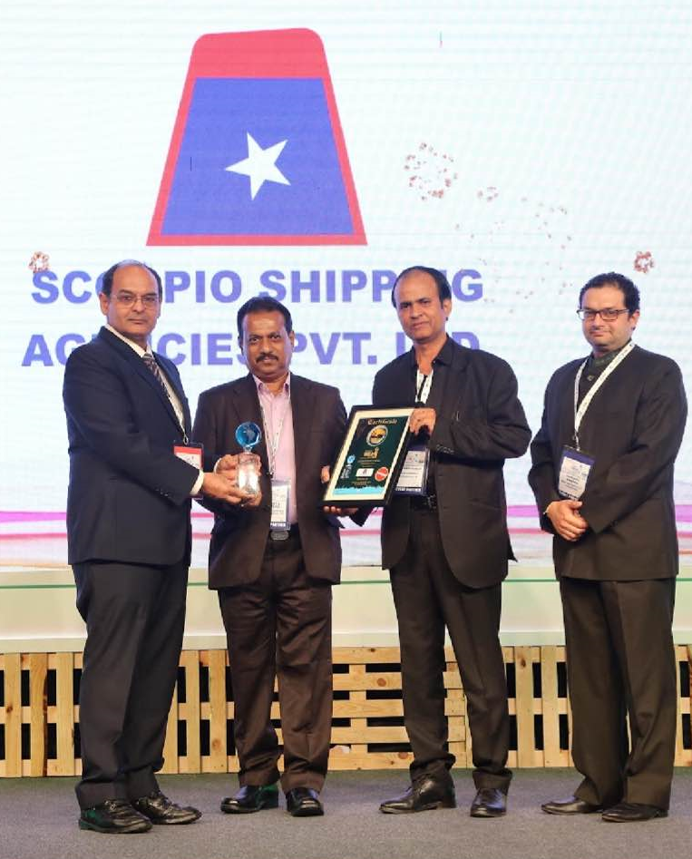

In a Panel Discussion at ‘ CTL – BHP ‘ 2018 ‘ at ‘Goregaon Exhibition Centre , Mumbai ‘,
on January 23 ‘ 2018

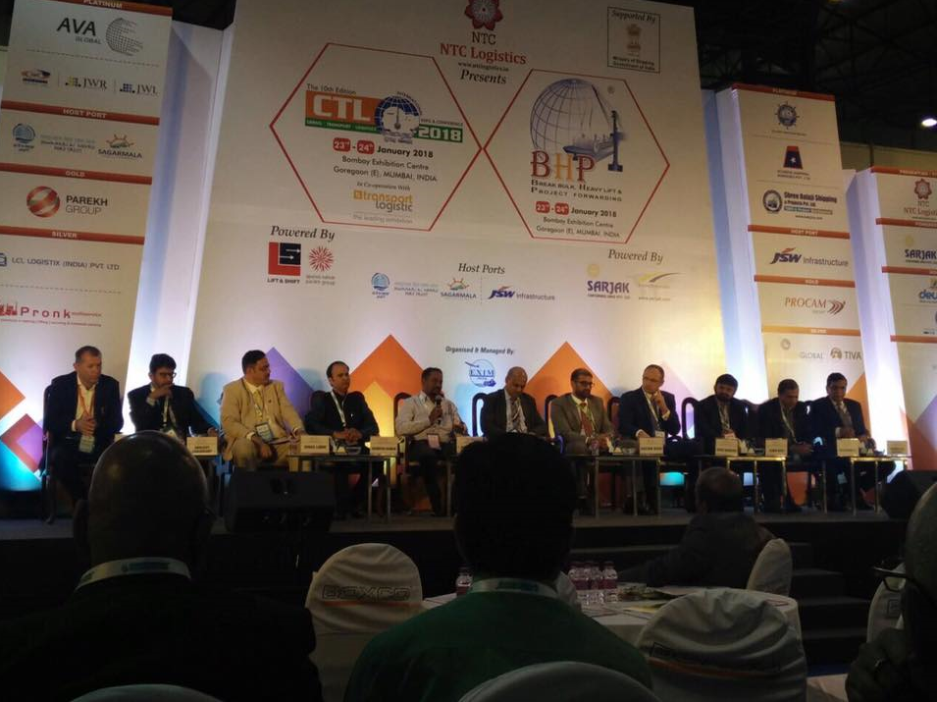

Views published by ‘The Link’ in its special issue for “ Breakbulk Europe 2017 “ for circulation at Antwerp , Belgium .

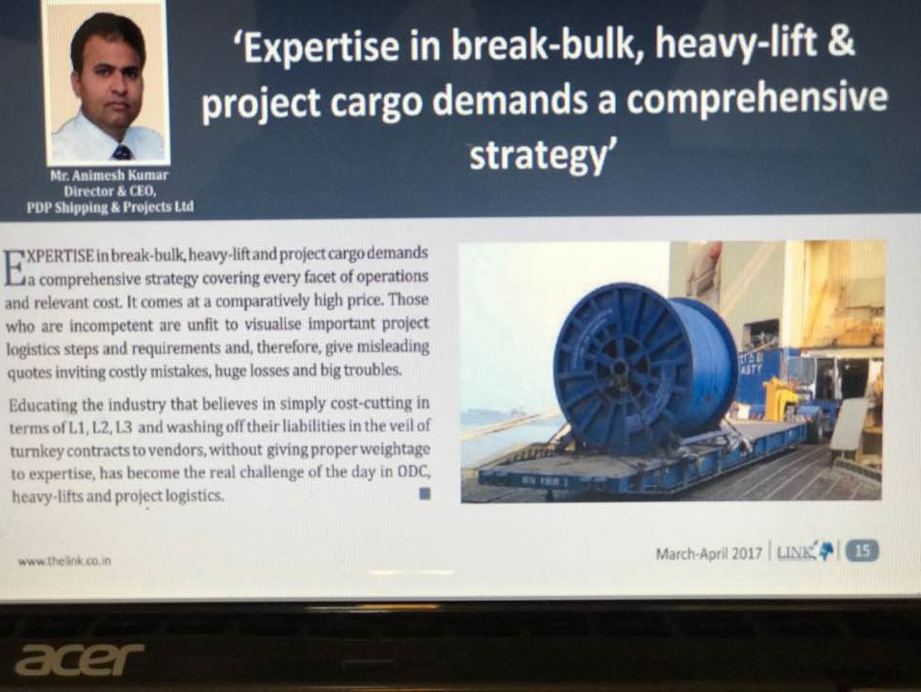

An Interview for magazine “ Cargo Connect “ in its issue August 2016

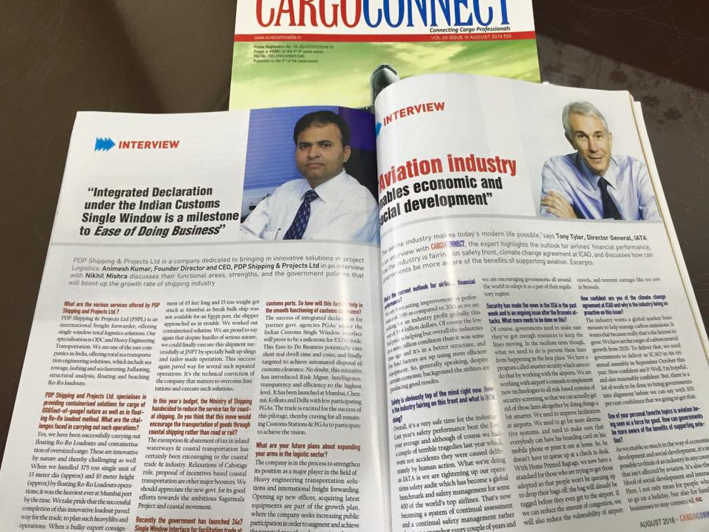

Statement in “ The Economic Times “ in Mumbai and New Delhi edition on dated 27/07/2016

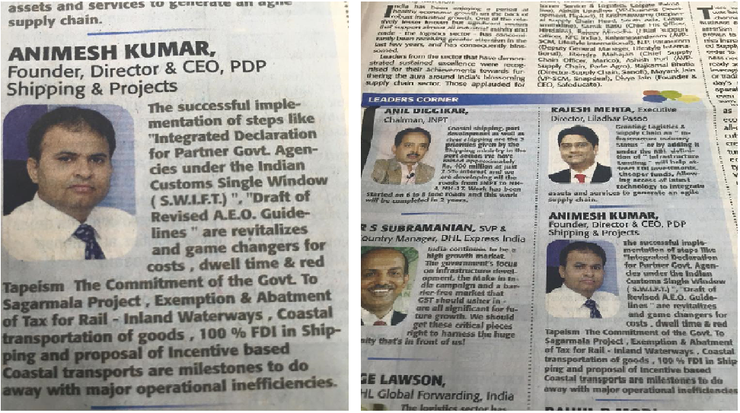

Mr Animesh Kumar as a Panelist & Advisor for The Economic Times for The ET SCM
Summit 2016 on 24th June 2016 at The Leela , Mumbai

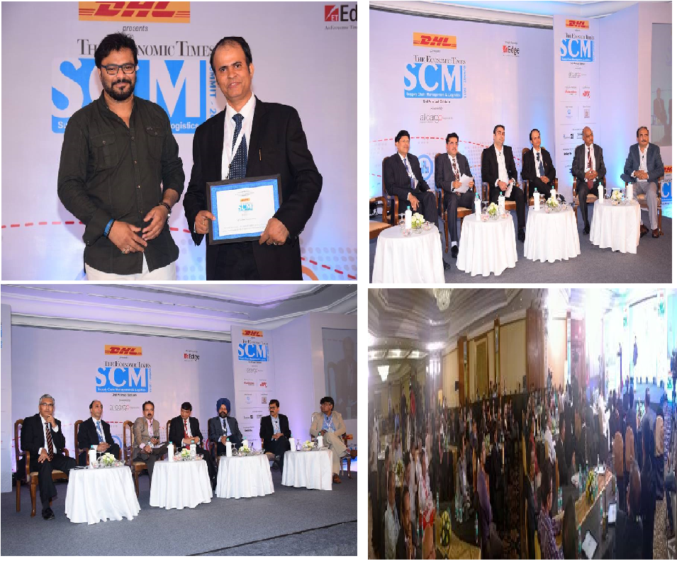

As a Panelist Speaker at CTL BHP-2016 for ‘Challenges & Opportunities in India in Project Logistics & Breakbulk cargo ‘ held at Bombay Exhibition Centre Goregaon on Feb 21’ 2016

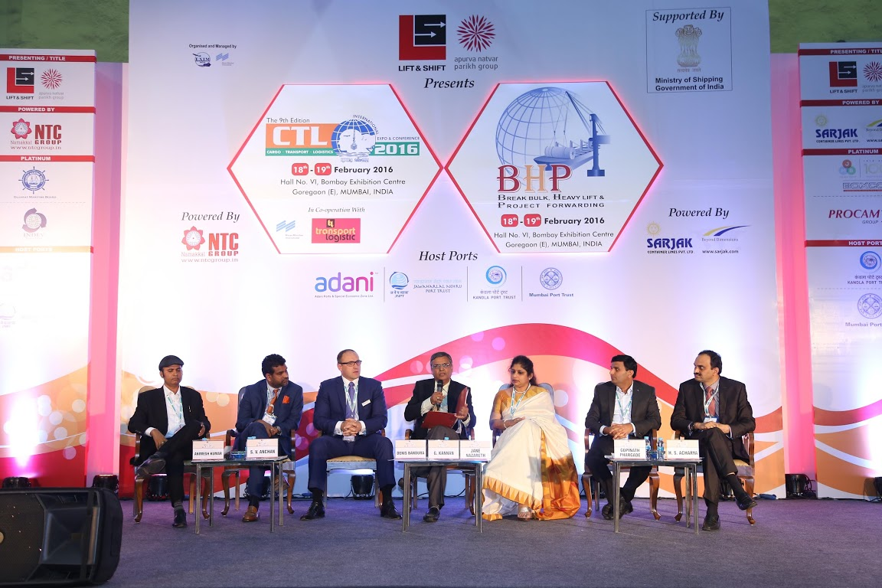

As a Jury for Prestigious “Maritime & Logistics Awards -2015 “ alonwith its Chairman Mr. Hajra ( Retd. Chairman of Shipping Corporation of India ) and Chief Guest Mr. N.N. Kumar ( Ex Chairman , Jawahar Lal Nehru Port Trust ) and other esteemed members.
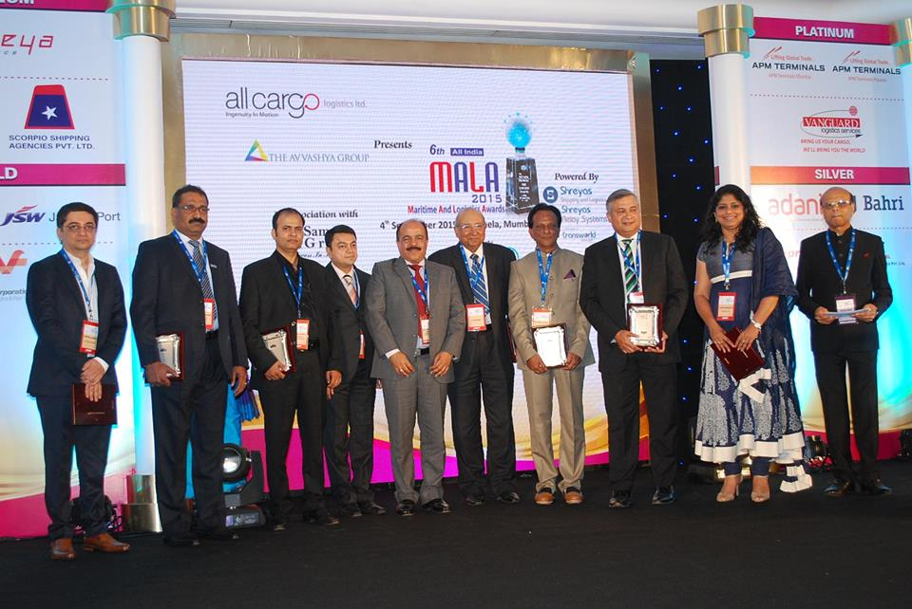
Presenting Best ICD Award to CONCOR ( a Govt. of India Enterprise ) at MALA Awards 2015
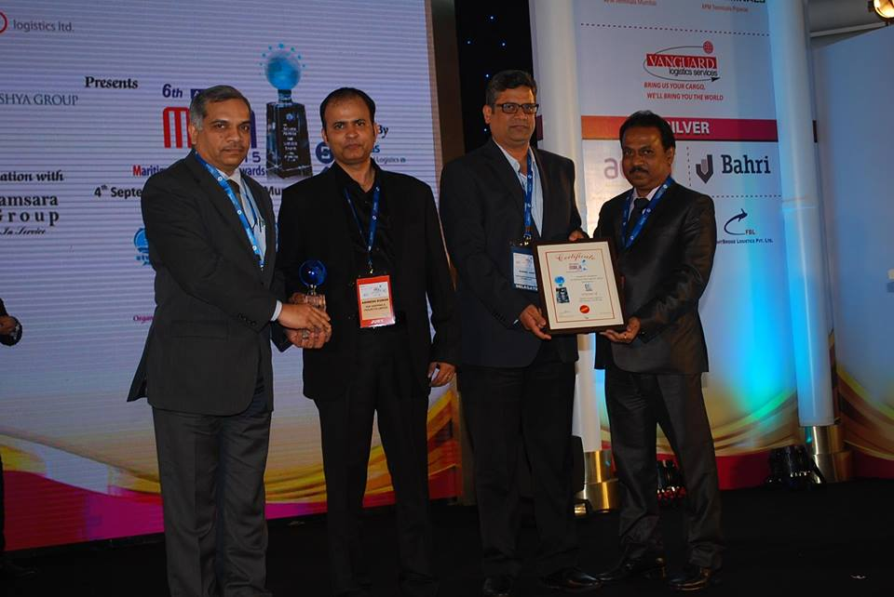

As a previleged Core Committee member for “Samudra Manthan Awards 2015” alongwith
Mr. D. T. Joseph , IAS & ex Secretary of GOI and Mr. S.S.Hussain , IAS & ex Chairman of JNPT, held on 06/11/2015 at Hyatt Regency , Mumbai.

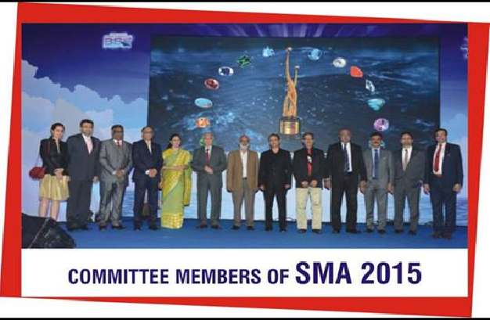

As a Panelist & Speaker for
ET SCM SUMMIT – 2015
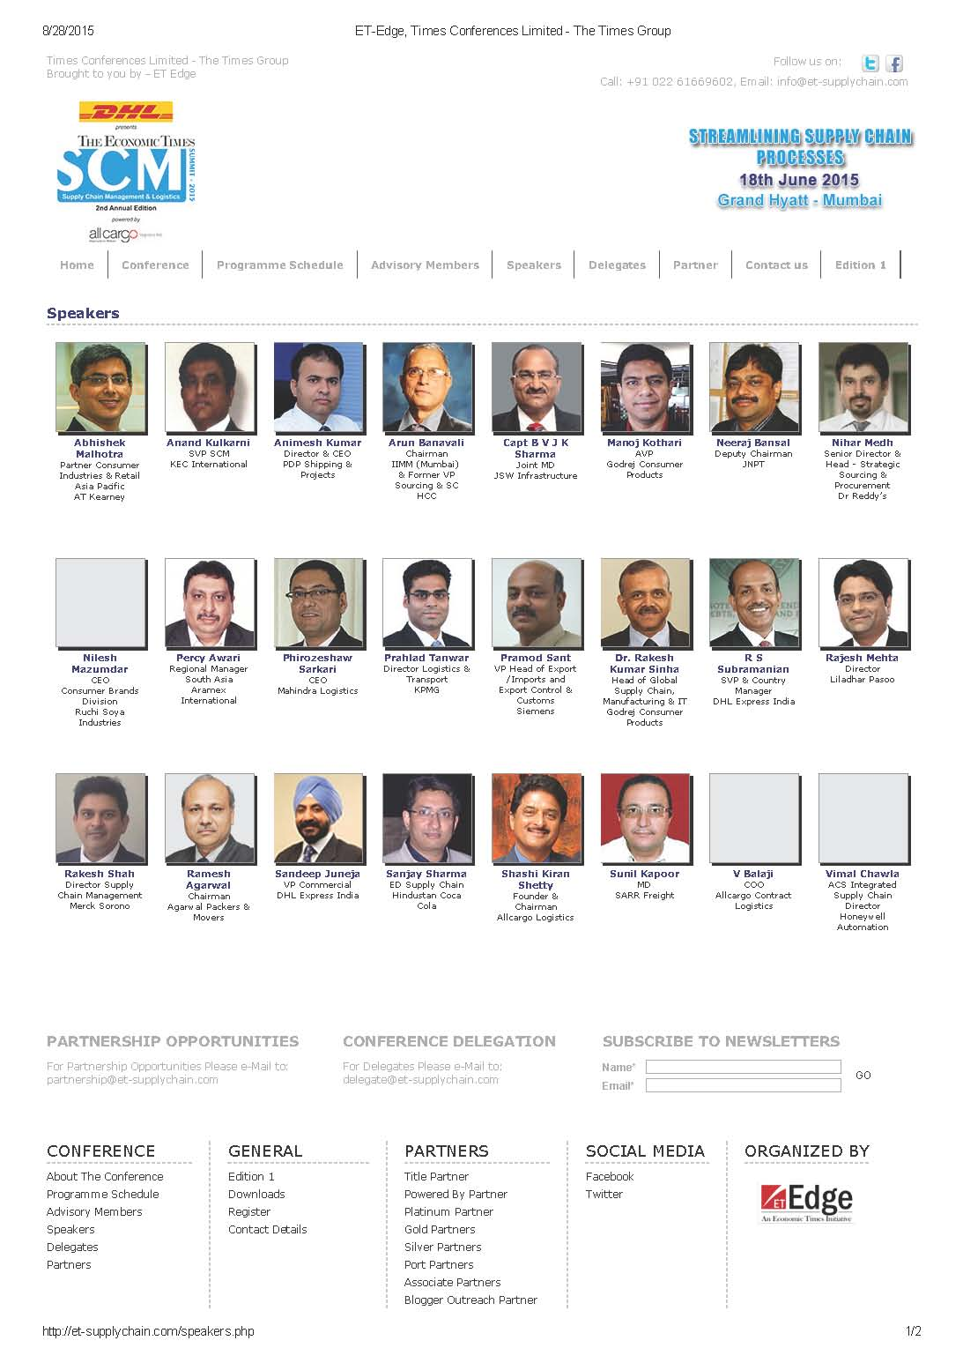

My statement in “ The Economic Times”, 6th August 2015 ,
Mumbai & New Delhi Edition
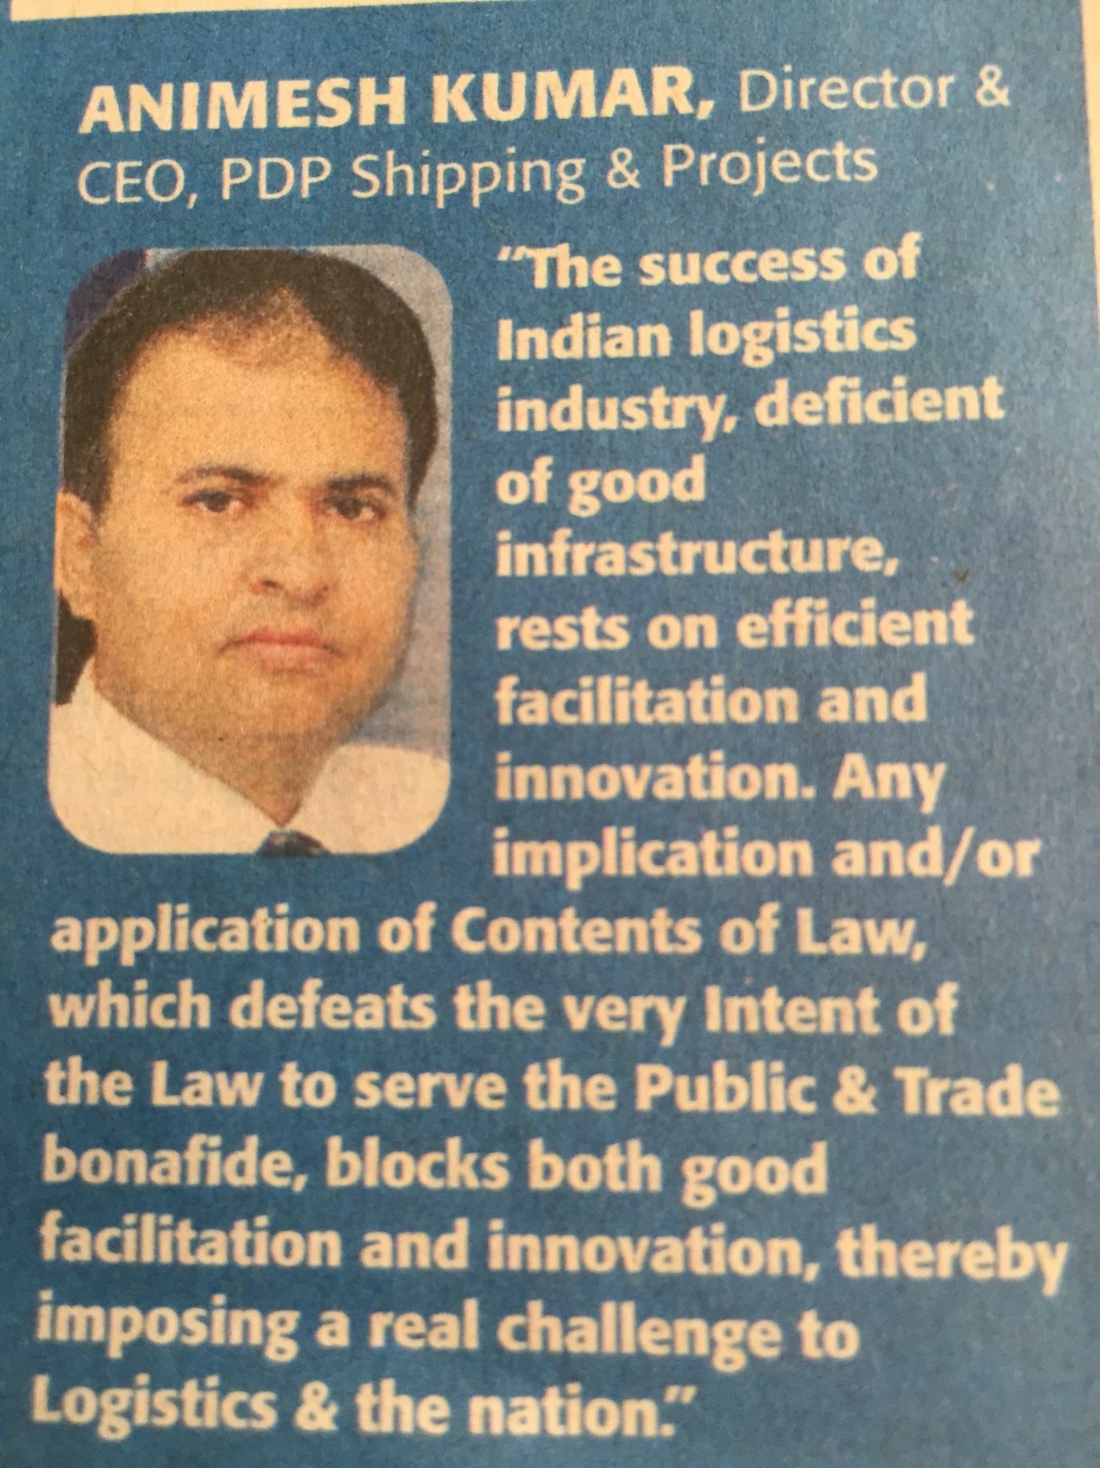

As a PANELIST & SPEAKER at
ET SCM SUMMIT – 2014
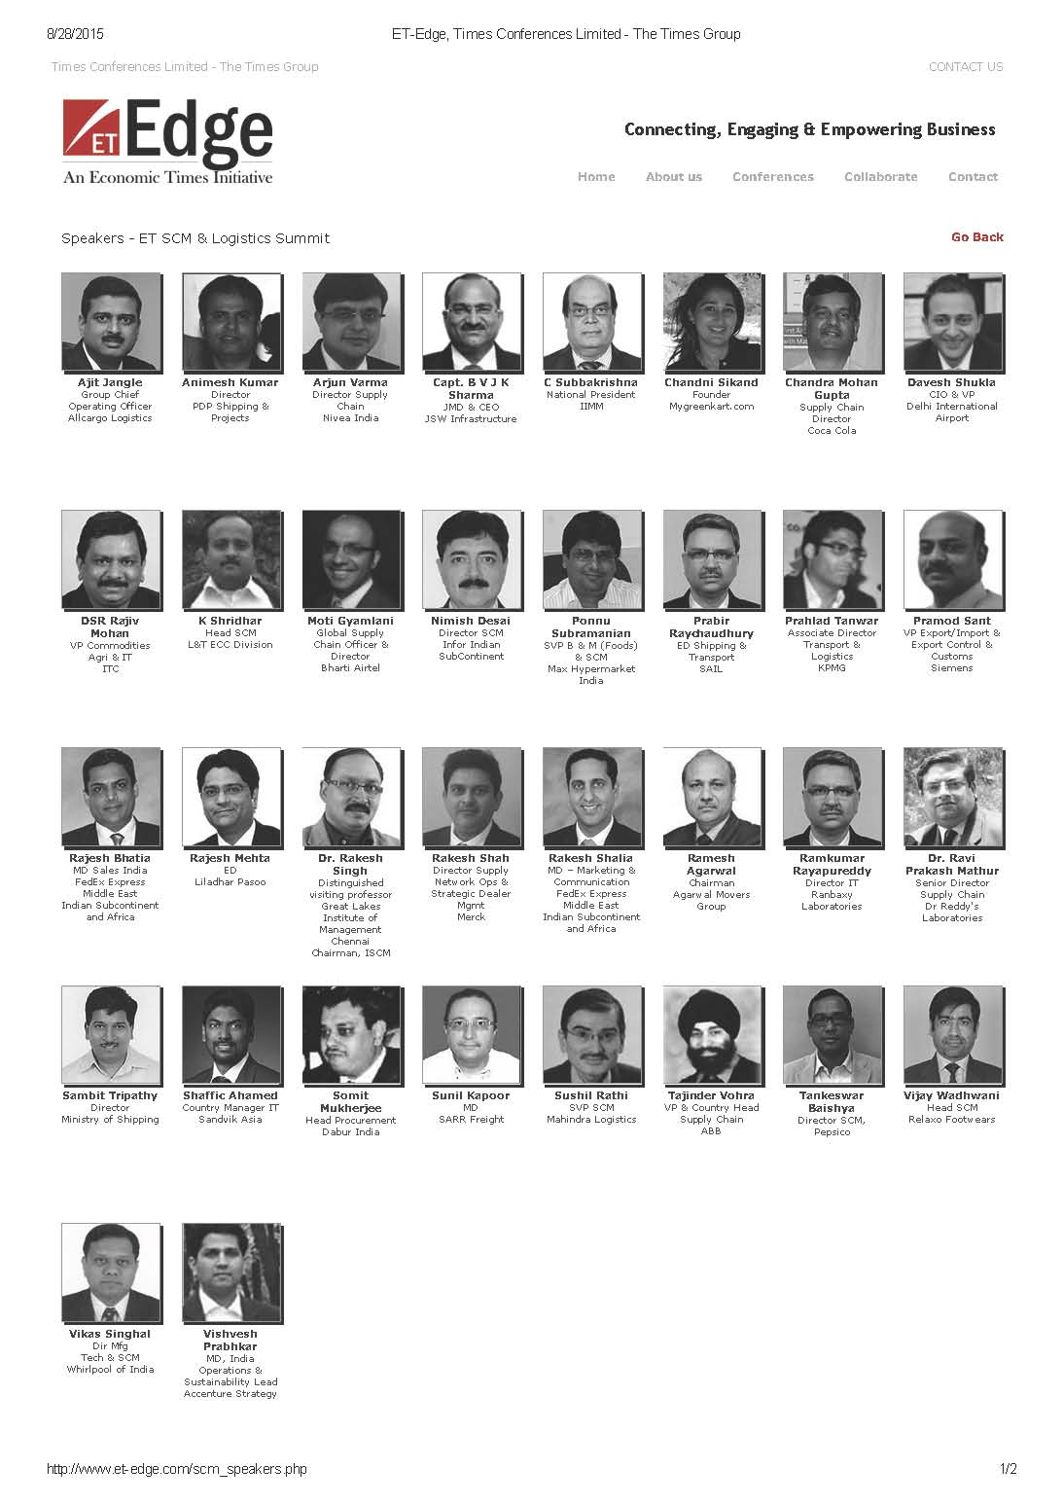

My statement in
The Economic Times, 24th July 2014 in Mumbai & Delhi edition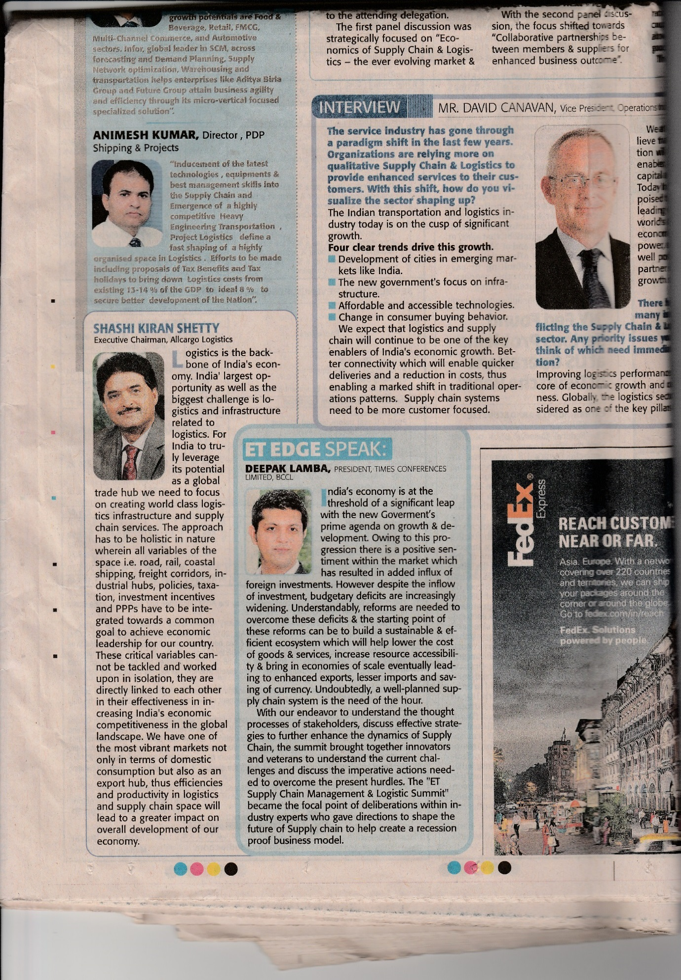

My Inyterview in “ Project Monitor “ .
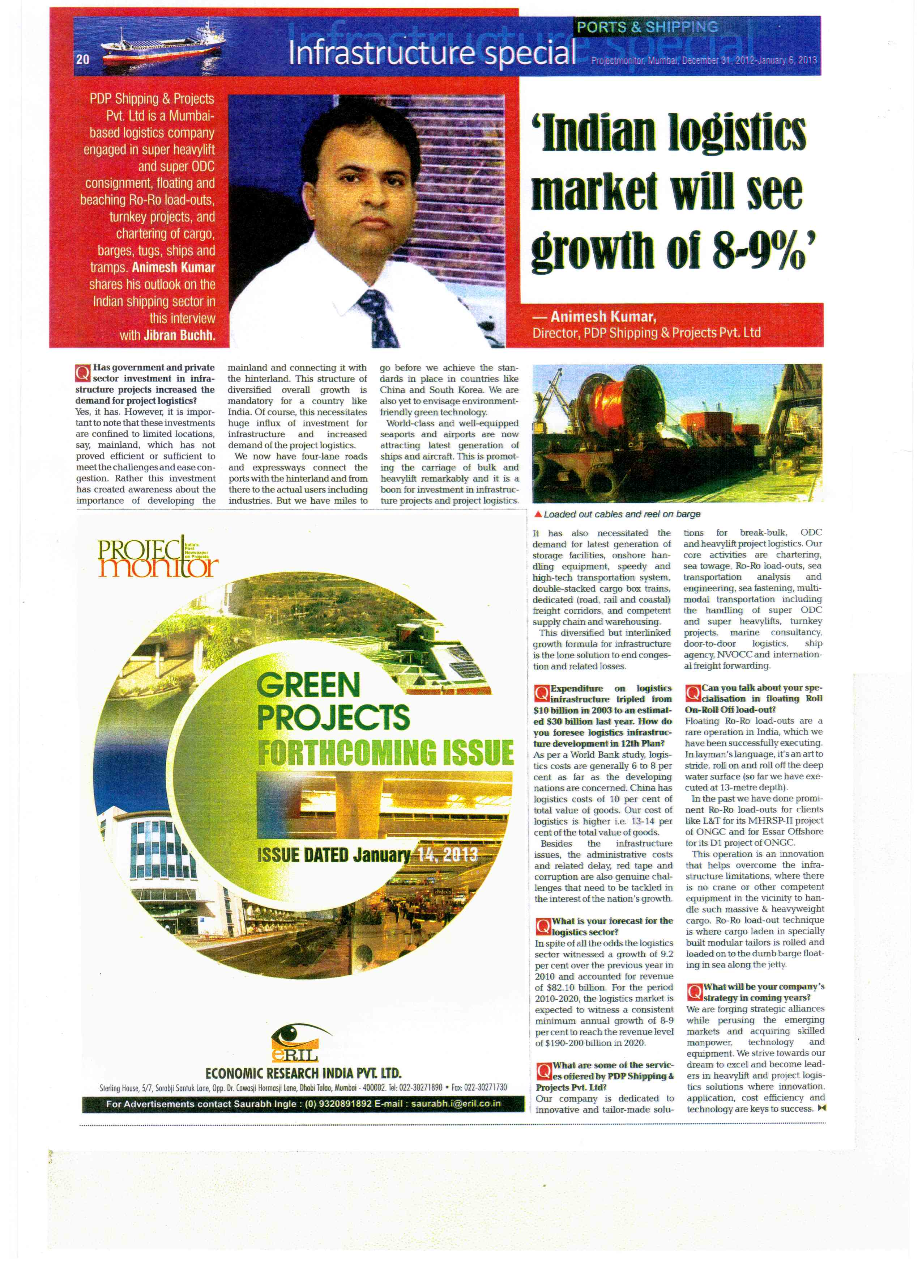

Our CEO facilitating the Honourable Union Cabinet Minister of Govt. of India
For Heavy Industries , Automobile and Public Enterprises Hon .
Mr. Anant Geete at an august gathering in Raigad , Navi Mumbai on 02/03/2019

